Siam GS Battery
PPC Dashboard User Manual
Production planning and control dashboard manual by AWS QuickSight
Nisarat Hawharn
7-25-2025

Document Control
# | Date | Author | Description | Reviewed by
1.0 | 25 July 2025 | Nisarat.h | Initial Release | Nisarat Hawharn

General Information

Introduction
This document serves as a formal reference for the management of the Production Planning Dashboard project deployed on the AWS QuickSight cloud platform. It is designed to support two distinct user groups: general users and administrative users. For general users, the document provides instructions on how to access and interact with the dashboard's visualizations. For administrative users, it offers detailed guidance on maintaining, configuring, and designing visuals to meet the information needs of general users.How to setting defaults

  - Precautions and usage instructions
    - Handling Visual Errors
If you faced with error visual situations as figure 1, please follow these steps:
- Locate and select the button at the top left corner of the screen, as the figure 2.
- This action will help you refresh or navigate away from the error screen as needed.
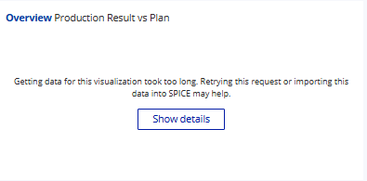
Figure 1 Visual error
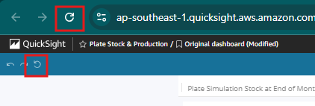
Figure 2 Refresh button for update new visual
    - Tips and Tricks
Here is tips and tricks for faster loading AWS QuickSight Dashboard, you able to open more than 1 tab to load dashboard at once, please follow these steps:
- Right-click the QuickSight logo located at the top-left corner of the screen, as shown in Figure 3.
- Select “Open link in new tab” or “Open link in new window” from the context menu.
- In the newly opened tab or window, select the desired dashboard you wish to view, as shown in Figure 4.

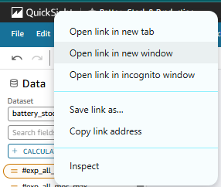
Figure 3 Open link in the new window or tab
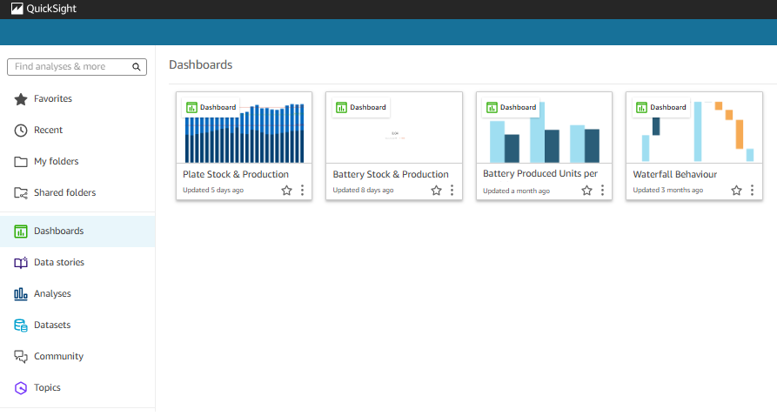
Figure 4 Select your dashboard
- Data source & Update Notice

Related Documents
As there is a requirement to update certain data from Excel files into the database, the following is a list of related documents used in the dashboard. Please ensure that the file naming format follows the guidelines specified below.Document of Battery Stock & Produciton dashboard
No | Excel Files | Example
1 | LEAD-SHEET-CAP-and-Sales-Rolling-N12 | LEAD-SHEET-CAP-and-Sales-Rolling-N12.xlsx
2 | PLATE-MASTERLIST_{YYYYMMDD-Rev No.} | PLATE-MASTERLIST_20250301-1.xlsx
3 | PLATE-TARGET-FY{YYYY-Rev No.} | PLATE-TARGET-FY2025-1.xlsx
4 | PLATE-CAP-and-Sales-Rolling-N12 | PLATE-CAP-and-Sales-Rolling-N12.xlsx
5 | STOCK-CAP-and-Sales-Rolling-N12_Rev{Rev No.} | STOCK-CAP-and-Sales-Rolling-N12_Rev1.xlsx
6 | PLAN-AMB-{MMM-YYYY-No} | PLAN-AMB-JUN-2025-1.xlsx
7 | STOCK-TARGET-FY{YYYY}-Rev{Rev No.} | STOCK-TARGET-FY2025-Rev-1.xlsx

How to Update Document
To ensure the dashboard reflects the most recent data, you are required to submit updated documents to the Data Engineer. Please follow the steps below:
- Update your Exel files and save them using the files naming format described in section 2.1
- Send the updated files to data engineer via email. Use the following subject line format:
[MVP Dashboard] Update Excel files-{MMM_YYYY} (e.g., [MVP Dashboard] Update Excel Files-Jul 2025)
- After receiving confirmation, you may view the updated data on your dashboard.

- How to Setting dashboard

Change title and subtitle
To modify the title or subtitle of a visual in AWS QuickSight, please follow the steps below:
- Select the visual you wish to edit. Once selected, a small toolbar will appear in the top-right corner of the chart.
- Click on ‘Format visual’ button ( ) . This will open the Properties panel on the right side of the screen.
Figure 5 Properties icon
- In the Display setting section, click the brush icon () next to the Title or Subtitle that you wish to change, as shown in Figure 6.
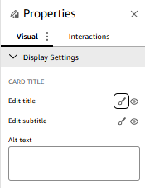
Figure 6 Edit title of visual
- A pop-up will appear, as the Figure 7, allowing you to edit the visual’s title as desired.
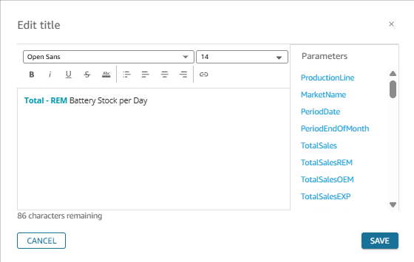
Figure 7 Title edition popup

Change Color of data series
- Click the visual to activate the toolbar.
- Right click on the data series that needs to change, as shown in the Figure 8
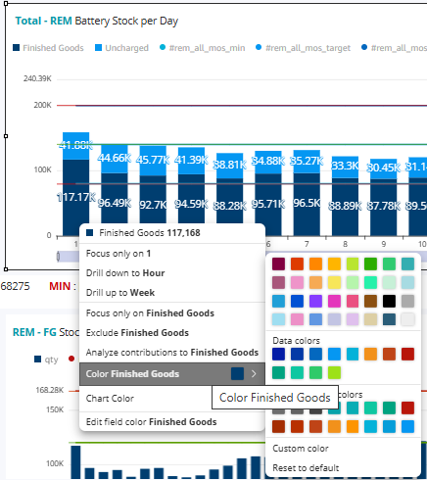
Figure 8 Change data series color
- Click on the color icon next to the series you want to change.
- Choose a new color from the palette or input a custom color code.

Setting Stock target and MOS
- Click the parameter activate the toolbar, as shown in the Figure 9.
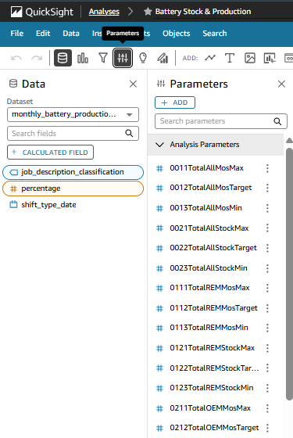
Figure 9 Parameter panel
- Search for Target on the parameter panal, as shown in the Figure10. And for the definition of parameter, you could see more details on the table below

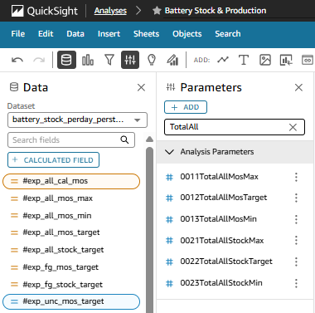
Figure 10 Search parameter
No. | Parameter | Type | Market | Batt. | Description
1 | 0011TotalAllMosMax | Mos | All | All | Max Mos of all market and all battery type.
2 | 0011TotalAllMosTarget | Mos | All | All | Target Mos of all market and all battery type.
3 | 0012TotalAllMosMin | Mos | All | All | Min Mos of all market and all battery type.
4 | 0021TotalAllStockMax | Stock | All | All | Max stock of all market and all battery type.
5 | 0022TotalAllStockTarget | Stock | All | All | Target stock of all market and all battery type.
6 | 0023TotalAllStockMin | Stock | All | All | Min stock of all market and all battery type.
7 | 0111TotalREMMosMax | Mos | REM | All | Max Mos of REM market for all battery type.
8 | 0112TotalREMMosTarget | Mos | REM | All | Target Mos of REM market for all battery type.
9 | 0113TotalREMMosMin | Mos | REM | All | Min Mos of REM market for all battery type.
10 | 0121TotalREMStockMax | Stock | REM | All | Max stock of REM market for all battery type.
11 | 0122TotalREMStockTarget | Stock | REM | All | Target stock of REM market for all battery type.
12 | 0123TotalREMStockMin | Stock | REM | All | Min stock of REM market for all battery type.
13 | 0211TotalOEMMosMax | Mos | OEM | All | Max Mos of OEM market for all battery type.
14 | 0212TotalOEMMosTarget | Mos | OEM | All | Target Mos of OEM market for all battery type.
15 | 0213TotalOEMMosMin | Mos | OEM | All | Min Mos of OEM market for all battery type.
16 | 0221TotalOEMStockMax | Stock | OEM | All | Max stock of OEM market for all battery type.
17 | 0222TotalOEMStockTarget | Stock | OEM | All | Target stock of OEM market for all battery type.
18 | 0223TotalOEMStockMin | Stock | OEM | All | Min stock of OEM market for all battery type.
19 | 0311TotalEXPMosMax | Mos | EXP | All | Max Mos of EXP market for all battery type.
20 | 0312TotalEXPMosTarget | Mos | EXP | All | Target Mos of EXP market for all battery type.
21 | 0313TotalEXPMosMin | Mos | EXP | All | Min Mos of EXP market for all battery type.
22 | 0321TotalEXPStockMax | Stock | EXP | All | Max stock of EXP market for all battery type.
23 | 0322TotalEXPStockTarget | Stock | EXP | All | Target stock of EXP market for all battery type.
24 | 0323TotalEXPStockMin | Stock | EXP | All | Min stock of EXP market for all battery type.
25 | 1011FGAllMosMax | Mos | All | FG | Max Mos of all market for FG
26 | 1012FGAllMosTarget | Mos | All | FG | Target Mos of all market for FG
27 | 1013FGAllMosMin | Mos | All | FG | Min Mos of all market for FG
28 | 1021FGStockMax | Stock | All | FG | Max stock of all market for FG
29 | 1022FGStockTarget | Stock | All | FG | Target stock of all market for FG
30 | 1023FGStockMin | Stock | All | FG | Min stock of all market for FG
31 | 1112FGREMMosTarget | Mos | REM | FG | Target Mos of REM market for FG
32 | 1121FGREMStockMax | Stock | REM | FG | Max stock of REM market for FG
33 | 1122FGREMStockTarget | Stock | REM | FG | Target stock of REM market for FG
34 | 1123FGREMStockMin | Stock | REM | FG | Min stock of REM market for FG
35 | 1212FGOEMMosTarget | Mos | OEM | FG | Target Mos of OEM market for FG
36 | 1221FGOEMStockMax | Stock | OEM | FG | Max stock of OEM market for FG
37 | 1222FGOEMStockTarget | Stock | OEM | FG | Target stock of OEM market for FG
38 | 1223FGOEMStockMin | Stock | OEM | FG | Min stock of OEM market for FG
39 | 1312FGEXPMosTarget | Mos | EXP | FG | Target Mos of EXP market for FG
40 | 1321FGEXPStockMax | Stock | EXP | FG | Max stock of EXP market for FG
41 | 1322FGEXPStockTarget | Stock | EXP | FG | Target stock of EXP market for FG
42 | 1323FGEXPStockMin | Stock | EXP | FG | Min stock of EXP market for FG
43 | 2011UNCAllMosMax | Mos | All | UNC | Max Mos of all market for Uncharge
44 | 2012UNCAllMosTarget | Mos | All | UNC | Target Mos of all market for Uncharge
45 | 2013UNCAllMosMin | Mos | All | UNC | Min Mos of all market for Uncharge
46 | 2021UNCAllStockMax | Stock | All | UNC | Max stock of all market for Uncharge
47 | 2022UNCAllStockTarget | Stock | All | UNC | Target stock of all market for Uncharge
48 | 2023UNCAllStockMin | Stock | All | UNC | Min stock of all market for Uncharge
49 | 2112UNCREMMosTarget | Mos | REM | UNC | Target Mos of REM market for Uncharge
50 | 2121UNCREMStockMax | Stock | REM | UNC | Max stock of REM market for Uncharge
51 | 2122UNCREMStockTarget | Stock | REM | UNC | Target stock of REM market for Uncharge
52 | 2123UNCREMStockMin | Stock | REM | UNC | Min stock of REM market for Uncharge
53 | 2212UNCOEMMosTarget | Mos | OEM | UNC | Target Mos of OEM market for Uncharge
54 | 2221UNCOEMStockMax | Stock | OEM | UNC | Max stock of OEM market for Uncharge
55 | 2222UNCOEMStockTarget | Stock | OEM | UNC | Target stock of OEM market for Uncharge
56 | 2223UNCOEMStockMin | Stock | OEM | UNC | Min stock of OEM market for Uncharge
57 | 2312UNCEXPMosTarget | Mos | EXP | UNC | Target Mos of EXP market for Uncharge
58 | 2321UNCEXPStockMax | Stock | EXP | UNC | Max stock of EXP market for Uncharge
59 | 2322UNCEXPStockTarget | Stock | EXP | UNC | Target stock of EXP market for Uncharge
60 | 2323UNCEXPStockMin | Stock | EXP | UNC | Min stock of EXP market for Uncharge

- Then click on the 3 point button to show pop-up window, then select ‘Edit parameter’ as the Figure 11.
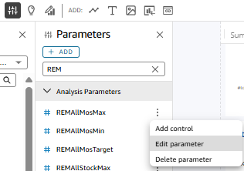
Figure 11 Edit parameter
- Then edit the target in each visual on the dashboard and click update button as shown in the Figure 12.
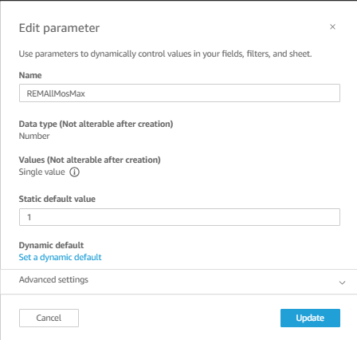
Figure 12 Update parameter

